Immunotherapy using slow-cycling tumor cells prolonged overall survival of tumor-bearing mice

Qing Sun1, Yong Zhong1, Fan Wu2, Chunxia Zhou1, Dongmei Wang1, Wenbo Ma1, Youhui Zhang1 and Shuren Zhang1*

1Department of Immunology, Cancer Hospital & Institute, Peking Union Medical College and Chinese Academy of Medical Sciences, Beijing 100021, China. 2Department of Abdominal Surgery, Cancer Hospital & Institute, Peking Union Medical College and Chinese Academy of Medical Sciences, Beijing 100021, China.

Abstract
Background: Despite considerable progress in the development of anticancer therapies, there is still a high mortality rate caused by cancer relapse and metastasis. Dormant or slow-cycling residual tumor cells are thought to be a source of tumor relapse and metastasis, and are therefore an obstacle to therapy. In this study, we assessed the drug resistance of tumor cells in mice, and investigated whether vaccination could promote survival.
Methods: The mouse colon carcinoma cell line CT-26 was treated with 5-fluorouracil to assess its sensitivity to drug treatment. Mice with colon tumors were immunized with inactivated slow-cycling CT-26 cells to estimate the efficacy of this vaccine.
Results: We identified a small population of slow-cycling tumor cells in the mouse colon carcinoma CT-26 cell line, which was resistant to conventional chemotherapy. To inhibit tumor recurrence and metastasis more effectively, treatments that selectively target the slow-cycling tumor cells should be developed to complement conventional therapies. We found that drug-treated, slow-cycling tumor cells induced a more intense immune response in vitro. Moreover, vaccination with inactivated slow-cycling tumor cells caused a reduction in tumor volume and prolonged the overall survival of tumor-bearing mice.
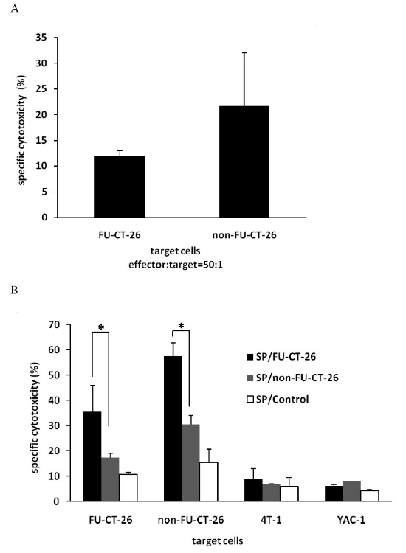
Cytotoxicity analysis using carboxyfluorescein diacetate succinimidyl estercarboxyfluorescein diacetate succinimidyl ester (CFSE)-propidium iodide (PI) staining-based Flow cytometry. CFSE- and PI-positive target cells represent cells lysed by effector cells. (A) Spleen cells from tumor-bearing mice killed fewer slow-cycling and drug-resistant 5-fluorouracil (FU)-treated CT-26 tumor cells. No significant differences were seen (t-test). (B) Spleen cells from tumor-bearing mice immunized with inactivated FU-CT-26 or non-FU-CT-26 cells showed tumor-specific cytotoxicity in vitro, and spleen cells from mice immunized with inactivated FU-CT-26 cells exhibited higher cytotoxicity compared with the other two groups. (*P < 0.05, **P < 0.01, t-test) Error bars represent the standard deviation. From left to right, the target cells respectively were FU-CT-26, non-FU-CT-26, 4T-1, and YAC-1 cells. Effector:target cell ratio was 50:1. SP/FU-CT-26: Spleen cells from tumor-bearing mice immunized with mitomycin C (MMC)-inactivated FU-CT-26 cells. SP/non-FU-CT-26: Spleen cells from tumor-bearing mice immunized with MMC-inactivated CT-26 cells. SP/Control: Spleen cells from tumor-bearing mice treated with PBS. Experiments were repeated three times with similar results.

Conclusions: These findings suggest that targeting of slow-cycling tumor cells application using immunotherapy is a possible treatment to complement traditional antitumor therapy.
Keywords: cancer relapse, drug resistance, slow-cycling tumor cells, tumor vaccine

